Downloadable Brochure
Update Version 03-06-06

Tow N’ Stow

Pressure Release Tow Bars
Tow N’ Stow manufactures two sizes of telescoping tow bars. The Standard tow bar is rated at 5,000 lbs. The Brute tow bar is rated at 7,500 lbs. With other tow hitches, it’s hard to remove the pin when un-hooking. With Tow N’ Stow, you back up before un-hooking, creating pressure. Relieve the pressure with the latch, which makes it easy to un-hook up hill or down. The tow bars have a safety stop to prevent injury. The Brute tow bar features the roller release latch shown in figure C. When the rollers are in the notch they prevent telescoping. When you turn one they both roll out, relieving the tow bar pressure. This latch releases under a tremendous amount of pressure. You can have 2-ton trucks backed against each other and relieve the pressure. Pins through four shiny eyebolts mount the tow bar to a vehicle, this makes the tow bar easy to remove. The tow bar can be folded flat under the bumper, with the eyebolts on angle irons that mount to the frame, as pictured. This is the most concealed method and works well on newer, rounded bumpers. The tow bar can be folded crossways on edge, or it can also be upright in an "A" position.

The eye bolts can also be mounted in the bumper. With extra eyebolt kits, you can use the tow bar on several vehicles
The picture shows a way to mount a tow bar on 88-99 Chevy pickups. A Brute tow bar is shown, and as mounted can be swung up in an "A" position. The left side of this photo shows the angle iron bolted to the frame that the eye bolts are mounted on. The shorter it is, the more concealed and protected the tow bar, but being shorter could loose the option to swing the bar up in an "A". A long angle iron connects the two short angle irons. This approach works on most late model trucks. Replace the tow hooks with eye bolts.
The Standard tow bar is available in either ball or clevis tongue.
Tow N' Stow also makes a barbwire gate latch that is opened by the bucket of a loader tractor. The bucket hits a rod above the gate, opening the gate.

Tow N’ Stow
Box 41
13592 77th St. NW
Zahl, ND 58856
Phone (701) 528-4712
E-mail tow@nccray.com
Web pages: http://web.nccray.com/tow

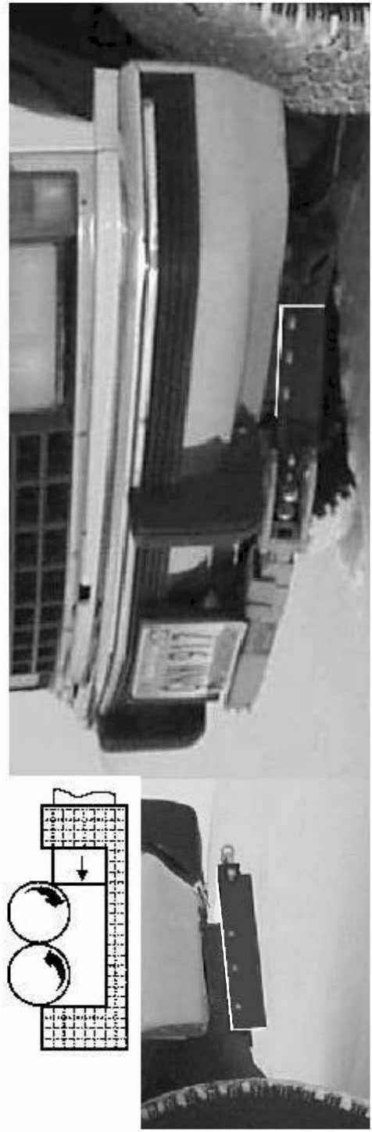

How to Work iT
- Back up before unhooking, compressing rollers.
- Turn one roller. Both roll out of notch.
- Pressure relieved. Unhooks easily.

Pry pin out of a hole with Ten to One Leverage. to release the pressure..

Receiver tubes at the right : one tube inside another, with a plate “C” to the frame, mount the shiny eye bolts. you can use the same tow bar on another vehicle with four extra eye bolts. variable eye bolt spacing. both towbars mount and fold up the same, and both are compatible with custom mounting brackets.

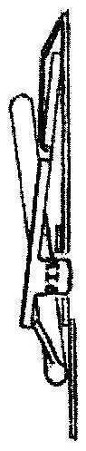

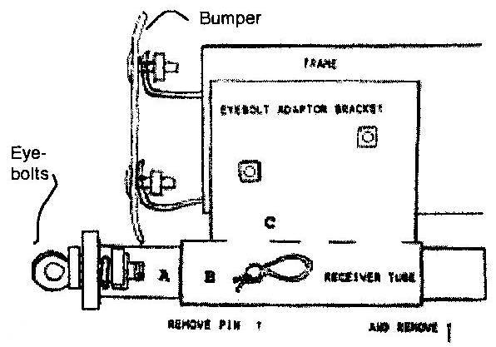

patent abstract
In the patent, the rollers are called extended and circular counterparts.
Coupling interacting members. The members together define an opening for their extended and circular counterparts. The counterparts turn on the members and each other, while the members contact the counterparts to urge them together; and the counterparts, one after another between the members, release the members.
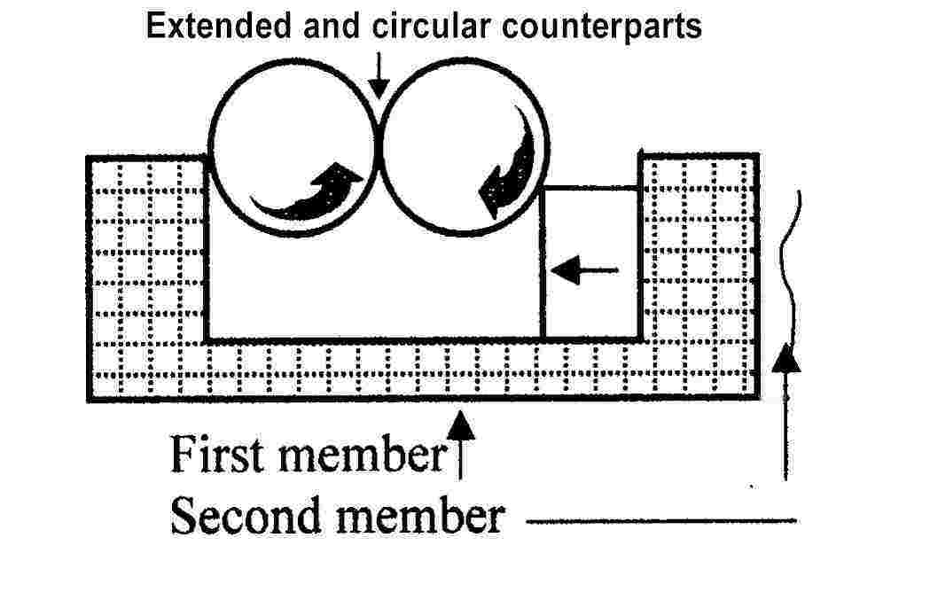

so why not call today?

Call 701-528-4712

